**GSM BASED AUTOMATION**

**A Project Report Submitted in Partial Fulfillment of the Requirements for the Degree**

**of**

**BACHELOR OF TECHNOLOGY**

**in**

**Computer Science and Engineering Department**

**by**

|  |  |
| --- | --- |
| **Pakhi Gupta** | **1516410170** |
| **Shashank Shukla** | **1516410246** |
| **Vishwendra Singh** | **1516410308** |
| **Shrishti Singh** | **1516410284** |

**Under the Supervision of**

**Mr. Deepak Kumar**

**(Associate Professor)**



**to the**

**Faculty of Computer Science and Engineering Department**

**Pranveer Singh Institute of Technology, Kanpur**

**DR. A. P. J. ABDUL KALAM TECHNICAL UNIVERSITY,**

**LUCKNOW**

**May, 2019**

**GSM BASED AUTOMATION**

**A Project Report Submitted in Partial Fulfillment of the Requirements for the Degree**

**of**

**BACHELOR OF TECHNOLOGY**

**in**

**Computer Science and Engineering Department**

**by**

|  |  |
| --- | --- |
| **Pakhi Gupta** | **1516410170** |
| **Shashank Shukla** | **1516410246** |
| **Vishwendra Singh** | **1516410308** |
| **Shrishti Singh** | **1516410284** |

**Under the Supervision of**

**Mr. Deepak Kumar**

**(Associate Professor)**



**to the**

**Faculty of Computer Science and Engineering Department**

**Pranveer Singh Institute of Technology, Kanpur**

**DR. A. P. J. ABDUL KALAM TECHNICAL UNIVERSITY,**

**LUCKNOW**

**May, 2019**

**DECLARATION**

We hereby declare that this submission of our own work and that, to the best of our knowledge and belief, it contains no material previously published or written by another person nor material which to a substantial extent has been accepted for the award of any other degree or diploma or the university or other institute of higher learning, except where due acknowledgement has been made in the text.

|  |  |
| --- | --- |
| **Signature:**  **Name: PAKHI GUPTA**  **Roll no: 1516410170**  **Date:** | **Signature:**  **Name: SHASHANK SHUKLA**  **Roll no: 1516410246**  **Date:** |
| **Signature:**  **Name: VISHWENDRA SINGH**  **Roll no: 1516410308**  **Date:** | **Signature:**  **Name: SRISHTI SINGH**  **Roll no: 1516410284**  **Date:** |

**CERTIFICATE**

This is to certify that the Project Report entitled **“GSM BASED AUTOMATION”** which is submitted by **PAKHI GUPTA (1516410170)**, **SHASHANK SHUKLA (1516410246)**, **VISHWENDRA SINGH (1516410308), SRISHTI SINGH (151640284)** of the 8th semester, in the year 2018-2019.

In partial fulfillment of the requirement for the award of degree of B.Tech in department of **Computer Science & Engineering** of **APJ Abdul Kalam Technical University** is a record of the candidate own work carried out by him/her under my supervision. The matter embodied in this thesis is original and is not been submitted for the award of any degree.

Signature

(Mr. Deepak Kumar)

(Asst. Professor)

(Department of Computer Science & Engineering)

Date:

# ACKNOWLEDGEMENT

It gives us a great sense of pleasure to present the report of the B.Tech Project undertaken during **B.Tech Final Year**. We owe special debt of gratitude to our guide **Mr. Deepak Kumar** of Department of **Computer Science & Engineering, Pranveer Singh Institute of Technology, Kanpur (U.P)** for his constant support and guidance throughout course of our work. His sincerity, thoroughness and perseverance have been a constant source of inspiration for us. It is only his cognizant efforts that our endeavors have been light of the day.

We also take the opportunity to acknowledge the contribution of **Prof (Dr.) Vishal Nagar Head of Department of Computer Science & Engineering, Pranveer Singh Institute of Technology, Kanpur (U.P.)** for his full support and assistance during the development of the project.

We also do not like to miss the opportunity to acknowledge the contribution of all faculty members of the department for their assistance and cooperation during the development of my project. Last but not the least, we acknowledge our friends for their contributions in the completion of the project.

# ABSTRACT

This thesis presents a GSM based automated home system by using Arduino microcontroller. Here in this project we are providing the automation system in which we can control the electrical devices from anywhere. This system is distance independent as we are using the GSM technology. Hence the GSM sim card enables us to access the system from areas with low connectivity network. Whatever the functions will be taking place, they will be displayed on the LCD screen. Further the person can control all his appliances power from an android application installed on their android devices. The android application enables the user to switch on/off their appliances by a single tap. This project is an energy efficient project and offers a smart approach towards living.

In the first module we have designed the circuit which includes GSM A6 module, Arduino Uno microcontroller, four connections for devices, a transformer, relays along with a LCD Screen and in the second module the hardware coding is done. We are using Arduino Un microcontroller and we are providing the power supply of 220 V so that the real-world appliances can also be added.

Overall this project is just a basic idea to design a system which can provide modern standard of living, security, energy efficiency, peace of mind and convenience in the day to day life using automation

**TABLE OF CONTENTS**

Contents

ACKNOWLEDGEMENT 5

ABSTRACT 6

LIST OF FIGURE 9

1. INTRODUCTION 10

1.1 HISTORY 11

1.2 MOTIVATION 14

1.4 PROBLEM STATEMENT 16

1.4.1 Problem detection 16

1.4.2 Problem Solving 17

1.5 OBJECTIVES 17

2. Working Model 19

2.1 System Design 19

2.2 Description 20

3.1 PIC Microcontroller [PIC 16F72] 22

3.1.1 Interfacing 24

3.1.2 Special Features of PIC 16F72 24

3.2Step Down Transformer 25

3.2.1 Specifications 25

3.2.2 Working 26

3.3 12 V SPDT Relay 26

3.3.1 Working 27

3.4 RF Tx/Rx (433-434 MHz) 28

3.4.1 Specifications 29

3.4.2Applications 29

3.5 LM 358 Op-amp (Comparator) 29

3.5.1 Specifications 30

3.5.2 Working Principle 31

3.5.3 Pin Configurations 31

3.6 16X2 Alpha-Numeric LCD 32

3.6.2 Features of 16×2 LCDmodule 34

3.7 4N35 Opto coupler IC 35

3.7.1 FEATURES 36

3.7.2 APPLICATIONS 37

3.7.3 DESCRIPTION 37

3.7.4 Pin Description 38

3.8 Photodiodes and IR Sensors 39

3.8.1 Principle of operation 40

3.8.2 IR Sensors 40

3.9 DVD Tray 41

3.10 Miscellaneous 42

3.10.1 Capacitor 42

3.10.2 Transistors 45

3.10.3BC547 Transistor Features 46

3.10.4 Diode IN4007 48

4.1 IDE (Integrated Development Environment) 51

4.2 PROTON COMPILER 52

4.2.1 What is the Proton Compiler? 52

4.2.2 A Word about code writting 52

4.3.3 Writing and compiling the program 53

4.3.4 Loading program to microcontroller 54

4.4.5 Troubleshooting in PIC microcontroller 55

5.2 Future Scope 58

5.3 Uses & Targets 58

5.4 Applications 59

5.5 Result & Analysis 59

5.6 Limitations 60

5.7References 60

Appendix 62

LIST OF FIGURES

Figure 2.1 1 Block Diagram of Model 19

Figure 2.2 1 To indicate Working of model 20

Figure 2.3 1 Image of the project 21

Figure 3.2 1 12-0-12 Center Tapped Transformer 25

Figure 3.2 2 Circuit Diagram of Transformer 26

Figure 3.3 1 Relay 27

Figure 3.3 2Systematic diagram of Relay 28

Figure 3.4 1 RF Rx/Tx(433.92MHz) 28

Figure 3.6 1 Pin Diagram 16X2 Alphanumeric LCD 33

Figure 3.6 2 Pin Diagram of PIC 16F72 34

Figure 3.6 3 Display picture of LCD 35

Figure 3.7 1 Display picture of Opto coupler sensors 36

Figure 3.7 2 4N35 Opto coupler IC 36

Figure 3.7 3 Pin Diagram of Optocoupler IC 38

Figure 3.7 4 Display picture of Opto Coupler IC 38

Figure 3.8 1Photodiodes used in our model. 39

Figure 3.8 2 Systematic diagram of Photodiode 40

Figure 3.9 1 DVD Tray 42

Figure 3.10 1 General Diagram of Capacitor 43

Figure 3.10 2 Image of electrolytic Capacitor 44

Figure 3.10 3 Basic Diagram of transistor BC547 47

Figure 3.10 4 Transistor BD139 48

Figure 3.10 5 Image of a real Diode 49

Figure 3.10 6 General Diagram of Diode 50

Figure 4.3 1 Basic program 53

Figure 4.4 1 HEX FILE 55

INTRODUCTION

This Project is a method of controlling home appliances automatically for the convenience of users. This technology makes life easier for the user, and saves energy by utilizing devices according to strict requirements. Controls can be as basic as dimming lights with a remote or as complex as setting up a network of items in the home that can be programmed using a main controller or even via cell phone from anywhere in the world.

An automation system can involve switching off electrical appliances like air-conditioners or refrigerators whenever a user desires to. An automation system can also be used at several places like banks, hospitals, labs and other sophisticated organizations to control their appliances from one place i.e. via their android device.

In the first module we have designed the circuit which includes GSM A6 module, Arduino Uno microcontroller, four connections for devices, a transformer, relays along with an LCD Screen and i2 the second module the hardware coding is done. We are using Arduino Uno microcontroller and we are providing the power supply of 220 V so that the real-world appliances can also be added.

Home automation as term suggests making home smart and automatic. In modern days latest home automation technologies help human being to make their life safer and more comfortable.

You can switch on and off the lights, fans, television, alarms etc. without going near to the switch. [Home automation services](https://www.chetu.com/solutions/home-automation.php) directly makes your lifestyle more comfortable and easier. Big amount of money can be saved by making house automated. You can switch off the lights and other electronics item from other rooms, which save electricity bills and also stops the wastage of electric power.

Overall this project is just a basic idea to design a system which can provide modern standard of living, security, energy efficiency, peace of mind and convenience in the day to day life using automation.

## 1.2 HISTORY

The concept of home automation has been around for a long time but the technology just wasn't there. Many science-fiction writers included it in stories, Ray Bradbury famously among them.

Science fiction that has fixated on smart home technology since, well, the beginning of science fiction – but it’s not just that. For centuries, the world’s greatest minds and most innovative inventors have been working toward technology that can almost think for itself. Here are a few of our favorite highlights:

1785: As for the remote control, you'll really need to set your time machine to "way back" mode -- think about the famous electrical genius Nikola Tesla, who first created one to control a toy boat. That was in 1898, in the days he was competing with Edison to figure these things out.

Early 1900s: Fast-forward a few centuries, and the Industrial Revolution has paved the way for the invention of the first home appliances. Granted, they weren’t smart but they were absolute game-changers for early 20th century folks – at least, the wealthy ones. 1901 saw the introduction of the first vacuum cleaner, and over the next few decades, the world’s minds rolled out the washing machine, clothes dryer, clothes iron, home refrigerator, electric dishwasher, garbage disposal, and many other home appliances that today we take for granted.

**1901 – 1920 - The invention of home appliances**– Although home appliances aren’t what we’d consider “smart,” they were an incredible achievement in the early twentieth century. These achievements began with the first engine-powered vacuum cleaner in 1901. A more practical electricity-powered vacuum was invented in 1907. Throughout two decades refrigerators would be invented, as well as clothes dryers, washing machines, irons, toasters, and so [much more](http://www.greatachievements.org/?id=3768)

1930s: By the 1930s, inventors had already turned their imagination to home automation. Although the technology was still many decades off, the World’s Fair introduced the concept of automated home and smart appliances. Spectators were, unsurprisingly, fascinated with the idea.

1950: Jack Kilby and Robert Noyce invent the computer chip – the building block for today’s smart home technology.

1951: UNIVAC I, the world’s first commercially available computer, is introduced to market. Consider UNIVAC I the great-great-great-great granddaddy of today’s smart controls, which are all, essentially, mini computers.

1964: The Uniscope 300, one of the first computer monitors, hits shelves. And what would computers, smart hubs, and smart device controls today be without digital displays?

1966: Though never commercially sold, ECHO IV was the world’s first home automation system. Invented by Jim Sutherland, the “Electronic Computing Home Operator” (hence, ECHO) could store recipes, relay messages, control a home’s temperature, churn out a grocery list, and turn appliances on or off.

**1966 – 1967 - ECHO IV and the Kitchen Computer**– Although it was never commercially sold, the ECHO IV was the first smart device. This clever device could compute shopping lists, control the home’s temperature and turn appliances on and off. The Kitchen Computer, developed a year later, could store recipes, but had the unfortunate tagline, “If she can only cook as well as Honeywell can computer” and therefore sold no models.

1969: DARPA introduces ARPAnet, the world’s first network – the precursor to the modern Internet and with it, all our Internet of Things (IoT) smart technologies.

In 1975, the first general purpose home automation network technology, [X10](https://en.wikipedia.org/wiki/X10_(industry_standard)), was developed. It is a communication protocol for electronic devices. It primarily uses [electric power transmission](https://en.wikipedia.org/wiki/Electric_power_transmission) wiring for signalling and control, where the signals involve brief [radio frequency](https://en.wikipedia.org/wiki/Radio_frequency) bursts of [digital data](https://en.wikipedia.org/wiki/Digital_data), and remains the most widely available. By 1978, X10 products included a 16 channel command console, a lamp module, and an appliance module. Soon after came the wall switch module and the first X10 timer.

1980s: [Home automation](https://myalarmcenter.com/services/home-automation) becomes commonplace, in the form of garage doors, home security systems, motion-sensing lights, fiber optics, thermostat controls, and other technology.

1981: A precursor to today’s wireless (802.11) technology is invented.

1991: Ad van Berlo pioneers the field of gerontechnology – technology to improve the lives of senior citizens and the infirm. (Remember the 90s-era commercials, “Help! I’ve fallen and I can’t get up!”?) These early technologies form a firm base for the smart, life-enhancing features we love about today’s smart systems. Gerontechnology combines gerontology and technology and  makes the lives of senior citizens easier. In the 1990s, there was a lot of new research and technology in this sector.

1998-2000s: Smart homes became a thing. Throughout the late 1990s and early 2000s, smart technologies emerged, with gadgets and devices becoming more common and more affordable.**1998 – Early 2000s: Smart Homes**– Smart homes, or home automation, began to increase in popularity in the early 2000s. As such, different technology began to emerge. Smart homes suddenly became a more affordable option, and therefore a viable technology for consumers. Domestic technologies, home networking, and other gadgets began to appear on store shelves.

By 2012, in the United States, according to ABI Research, 1.5 million home automation systems were installed.

According to Li et al. (2016) there are three generations of home automation:

1. First generation: wireless technology with proxy server, e.g. Zigbee automation;
2. Second generation: artificial intelligence controls electrical devices, e.g. Amazon Echo;
3. Third generation: robot buddy who interacts with humans, e.g. Robot Rovio, Roomba.

**Today’s Smart Homes -** Today’s smart homes are more about security and living greener. Our smart homes are sustainable, and they help to ensure that our homes aren’t expending unnecessary energy. They also help alert us to intruders (whether we’re home or not).

automated thermostat adjustment, scheduling appliances, mobile/email/text notifications, and remote video surveillance.

The future: Only time will tell, but experts predict that soon, smart homes won’t be so far from The Jetsons as we once thought!

1.3 MOTIVATION

The motivation for developing smart home systems comes from many reasons, but most prominent are convenience, security, energy management, connectivity and luxury. Smart Automation systems are one of the newer areas of research that have not been fully integrated into our society. This is because the research requires many other disciplines of research and engineering to produce a functional smart home. The cost of installing a smart home is also a large hindrance to the emergence of smart home systems into the market. The extra cost of the install is from the fact that even though a majority of homes were built in the near past, technology has been growing exponentially. This means that most homes were built before this technology was available, and this creates a barrier for the development and sales of smart home systems. However, the technology is becoming better and cheaper, and this will help to make smart home systems an expense worth having when new homes are being built.

The biggest motivation behind smart home systems is the convenience. Convenience is really another way of saying – time saver, and into day’s world where everything is moving faster, every second has value. Most of the technology we use today is based of convenience, for example cars get us where we need to go faster, phones get us information from other people faster, and computer’s get work done faster. Smaller conveniences in the home will be desirable because they allow the home to save the user time as well. There are already many convenient technologies in the home like the dishwasher, washing machine, and microwave ovens. These technologies are more mechanical in nature and often there are much less computerized conveniences in the home. A Smart home systems goal is to introduce the benefits of computerized technology. For example, when using the smart home system, the user will not need to walk around turning off lights, they can save that little bit of extra time by just pressing a button on their phone, or even have the lights programmed to shut off after a certain amount of time. Maybe there is some music on the user’s computer they would like to play on a sound system, smart home systems will allow the user to play the music from where ever they are without needing to go to their computer, find the song, and make sure the song is in a playable format for their sound system. There are many other small conveniences provided from the smart home.

Security is also a big factor in the emergence of smart home systems. With a sophisticated enough system, home security becomes a powerful tool that gives piece of mind and power to the user. Security systems are also a large deterrent for crime. The mere presence of a camera will put doubt in any criminals’ mind about committing a crime. There are already many security automation systems on the market available and in use today, however integrating the security system into the smart home gives the user a one stop access to everything in their home. If the smart home system integrates the smart phone into the system then this means that the user will always know the status of the security of their home.

Energy management has become a huge factor in deciding anything, due to the trend of increasing cost of energy. As civilization grows, it constantly needs more energy to power itself. This leads to heavy pressure on efficient use of energy. Smart Home systems help the user do this and save them money at the same time. The smart home system is able to monitor certain process that use energy in the house and can control the amount of energy being used. A primary example would be with lights. Lights are often left on when they don’t need to be. A smart home system can be set to turn that light off after a certain amount of time. Maybe the user doesn’t like that feature because lights will turn off randomly when they

are watching TV or lying in bed. The smart home system allows the user control from his phone so it can be turned off, or set to turn off. This is also the case with many items that use electric power. Giving the user the control to turn things off like the AC, water heater, and TVs or computers allows the user to be more conscious of the energy use and control it accordingly.

Luxury is also a factor in the smart home systems that are currently in use. Because of the high cost of smart home system, only those that can afford it will be able to use a smart home system. The high cost causes other reasons to be less prominent when deciding the motivations for a smart home. However, luxury is not as concerned with cost and will not lose its value as significantly due to high cost.

**1.4 SCOPE OF THE PROJECT**

* This project is helpful in the industrial areas and in huge companies where the management will become quite easier and smarter.
* It focuses on reducing the energy consumption hence we can save a huge amount from electricity bills.
* This project also helps in security and safety purposes.
* It basically makes the life much easier and more luxurious and gives a peace of mind.

## 1.5 PROBLEM STATEMENT

## 1.5.1 Problem detection

* **Installation**  
  Depending on the complexity of the system, installing a home automation device can be a significant burden on the homeowner. It can either cost you money if you hire an outside contractor or cost you time if you venture to do it yourself.
* **Complex Technology**  
  Automating everything in life may sound extremely appealing, but sometimes a good old-fashioned flip of the switch is a lot easier than reaching for your smart phone to turn lights on and off. Before you decide which system is right for you, think about how far you really want to take home automation in your household.
* **Cost**  
  Even though the price of home automation systems has become much more affordable in recent years, the cost to purchase and install a device can still add up. Consumer Reports offers a wide range of information and insights – including costs – on the best home automation systems on the market.
  + 1. **Problem Solving**
* **Energy Savings**  
  Home automation systems have definitely proven themselves in the arena of energy efficiency .In this project we have added a feature of tapping so that once you enter the room just by a single tap, the fans will be opened because in winters we don't want fans to be ON hence they won't be automatically opened their ON and OFF will depend on our choice.
* **Convenience**   
  In today’s fast-paced society, the less you have to worry about, the better. Convenience is another primary selling point of home automation devices, which virtually eliminate small hassles such as turning the lights off before you go to bed or adjusting the thermostat when you wake up in the morning.
* **Security**  
  whenever the door opens or closes or any activity takes place at home each and every thing will be displayed on LCD to keep a track and to maintain security.

## 

## 1.6 OBJECTIVES

* The concept behind the idea is to provide a simpler and a easier way of living by using an automation system.
* In the first module we have designed the circuit using Arduino uno and GSM A.6.
* In the second module the concept of home automation will be portrayed by using embedded system
* In the third module we have designed an android application to provide a GUI to control the devices.
* The activities happening inside the house are displayed on the LCD display which keeps the track and provide security. In addition to this, the same is reflected on the android application.
* Overall this project is just a basic idea to design a system which can provide security, energy efficiency, peace of mind and convenience in the day to day life using automation.

# Working Model

## 2.1 System Design

In this project we have designed a general model in which we are having a home automation system, based on GSM. We are basically using a microcontroller (Arduino uno) to produce signals and pass them to the respective modules.

Firstly, we have connected the microcontroller with the GSM A6 module and LCD screen which will display the command executed. Then it is connected to the devices through the relays, to providing switching. For the convenience of the user, am android application can be installed on their android devices. Upon successful registration, the user can control the connected devices by a simple tap.

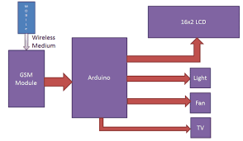

Figure 2.1: Block Diagram of Model

## 

## 2.2 Description

In our automation system, we are referring the modes of working model. It is getting signals through the GSM sim inserted in the A6 module and provides the information to the Arduino uno then it again transmits the signal to execute the given command.

E.g. when we are entering the house, we can see on the application the state of each device. We can then turn on or off a particular device as per our need. After that the text message will be sent to the GSM sim, and the given command will be executed as per the users choice.

**Figure 2.2 1 To indicate Working of model**

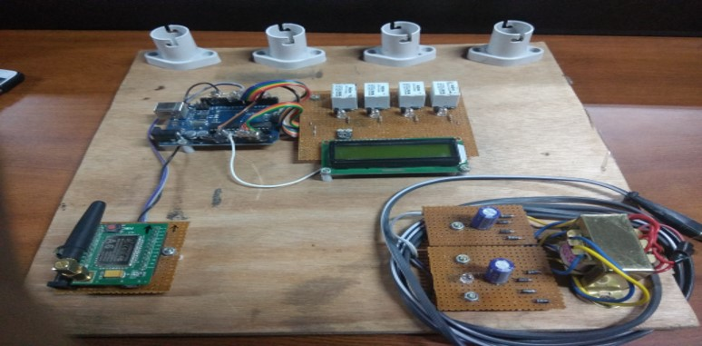

Figure 2.3 1 Image of the project

|  |  |
| --- | --- |
|  |  |

**Figure** **2.3.2:** Screenshot of the application

3.1 Arduino Microcontroller [Uno]

**Arduino Uno** is a microcontroller board based on 8-bit ATmega328P microcontroller. Along with ATmega328P, it consists other components such as crystal oscillator, serial communication, voltage regulator, etc. to support the microcontroller. Arduino Uno has 14 digital input/output pins (out of which 6 can be used as PWM outputs), 6 analog input pins, a USB connection, A Power barrel jack, an ICSP header and a reset button.

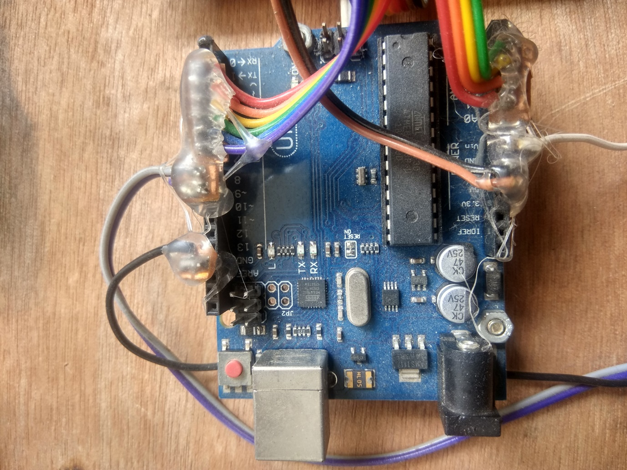

Figure3.1 1 Arduino Uno Architecture

The pin configuration of the microcontroller is shown in figure.

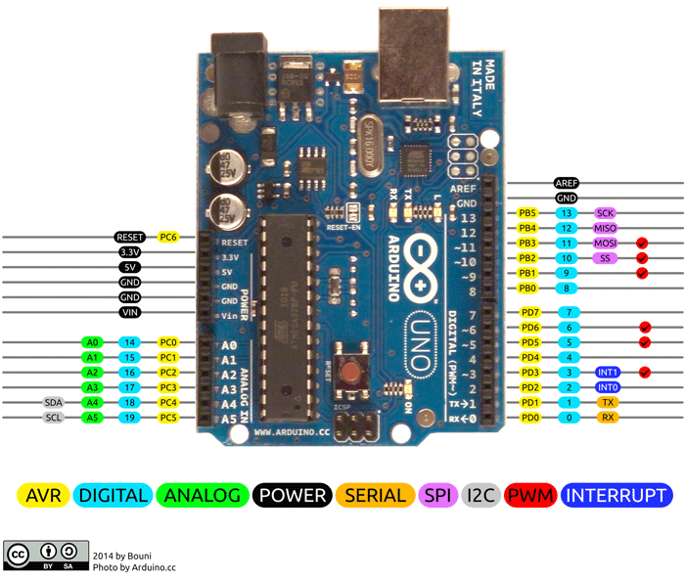

Figure3.1 2 Pin Diagram of Arduino Uno

### 3.1.1 Interfacing

Arduino can be used to communicate with a computer, another Arduino board or other microcontrollers. The ATmega328P microcontroller provides UART TTL (5V) serial communication which can be done using digital pin 0 (Rx) and digital pin 1 (Tx). An ATmega16U2 on the board channels this serial communication over USB and appears as a virtual com port to software on the computer. The ATmega16U2 firmware uses the standard USB COM drivers, and no external driver is needed. However, on Windows, a .inf file is required. The Arduino software includes a serial monitor which allows simple textual data to be sent to and from the Arduino board. There are two RX and TX LEDs on the arduino board which will flash when data is being transmitted via the USB-to-serial chip and USB connection to the computer (not for serial communication on pins 0 and 1). A SoftwareSerial library allows for serial communication on any of the Uno's digital pins. The ATmega328P also supports I2C (TWI) and SPI communication. The Arduino software includes a Wire library to simplify use of the I2C bus.

### 3.1.2 Special Features of PIC 16F72

* Microcontroller: ATmega328
* Operating Voltage: 5V
* Input Voltage (recommended): 7-12V
* Input Voltage (limits): 6-20V
* Digital I/O Pins: 14 (of which 6 provide PWM output)
* Analog Input Pins: 6
* DC Current per I/O Pin: 40 mA
* DC Current for 3.3V Pin: 50 mA
* Flash Memory: 32 KB of which 0.5 KB used by bootloader
* SRAM: 2 KB (ATmega328)
* EEPROM: 1 KB (ATmega328)
* Clock Speed: 16 MHz

## 3.2Step Down Transformer

A **centre-tapped transformer** also known as **two phase three wire transformer** is normally used for rectifier circuits. When a digital project has to work with AC mains a Transformer is used to step-down the voltage (in our case,24V to 12V) and then convert it to DC by using a rectifier circuit. In a center-tapped transformer the peak inverse voltage is twice as in bridge rectifier hence this transformer is commonly used in full wave rectifier circuits.

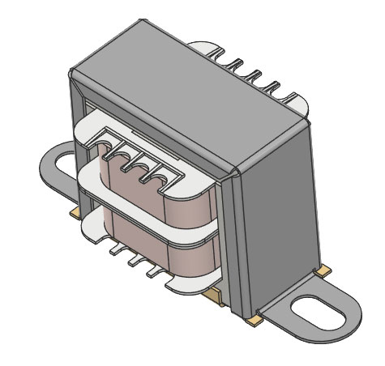

Figure 3.2 12-0-12 Center Tapped Transformer

### 3.2.1 Specifications

* Input Voltage: 220V AC at 50Hz
* Output Voltage: 24V, 12V or 0V
* Output Current: 1A
* Vertical mount type
* Low cost and small package

### 3.2.2 Working

The operation and theory behind a Center tapped transformer is very similar to a normal secondary transformer. A primary voltage will be induced in the primary coil (I1 and I3) and due to magnetic induction the voltage will be transferred to the secondary coil. Here in the secondary coil of a centre tapped transformer, there will be an additional wire (T2) which will be placed exactly at the center of the secondary coil, hence the voltage here will always be zero.

If we combine this zero potential wire (T2) with either T1 or T2, we will get a voltage of 12V AC. If this wire is ignored and voltage across T1 and T2 is considered then we will get a voltage of 24V AC. This feature is very useful for the function of a full wave rectifier.

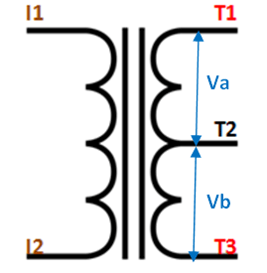

Figure 3.2 Circuit Diagram of Transformer

## 3.3 Relay

The Single Pole Double Throw SPDT [relay](https://www.arrow.com/en/products/relays) is quite useful in certain applications because of its internal configuration. It has one common terminal and 2 contacts in two different configurations: one can be [Normally Closed](https://www.electroschematics.com/9595/normally-closed-relay-switch/) and the other one is opened or it can be [Normally Open](https://www.electroschematics.com/9593/normally-open-relay-switch/) and the other one closed. So basically the SPDT relay as a way of switching between 2 circuits: when there is no voltage applied to the coil one circuit “receives” current, the other one doesn’t and when the coil gets energized the opposite is happening.

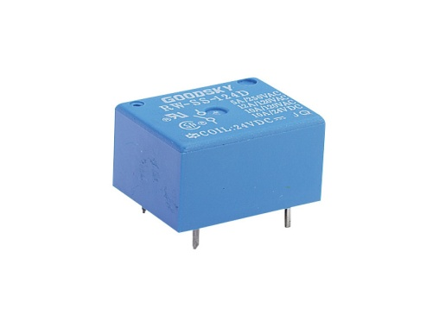

Figure 3.3 1 Relay

### 3.3.1 Working

A relay is a electromagnetic switch. Its basic function is to allow a low power control voltage operate a high power switch. The control and the switch are electrically isolated from each other and they have their own voltage and current ratings/requirements.

The Coil Terminals control the switch. When voltage is applied across the coil it becomes an electromagnet. Its core attracts the switch armature and activates the switch.

The Common Terminal (COM), Normally Open Terminal (NO) and Normally Closed Terminal (NC) make up the switch contacts. How they're connected depends on the application.

When the coil is not energized, the COM terminal is connected to the NC terminal. When the coil is energized, the COM terminal connects to the NO terminal, as shown in the figure.

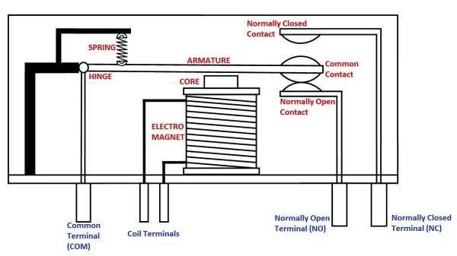

Figure 3.3 Systematic diagram of Relay

In our Project we are using four relays which will be further connected to the lights and fans of the house. This is an electromagnetic switch for controlling them.

## 3.4 GSM A6

A6 GSM/GPRS module is a miniature GSM modem, which can be integrated into a great number of IoT projects. You can use this module to accomplish almost anything a normal cell phone can; SMS text messages, Make or receive phone calls, connecting to internet through GPRS, TCP/IP, and more! To top it off, the module supports quad-band GSM/GPRS network, meaning it works pretty much anywhere in the world.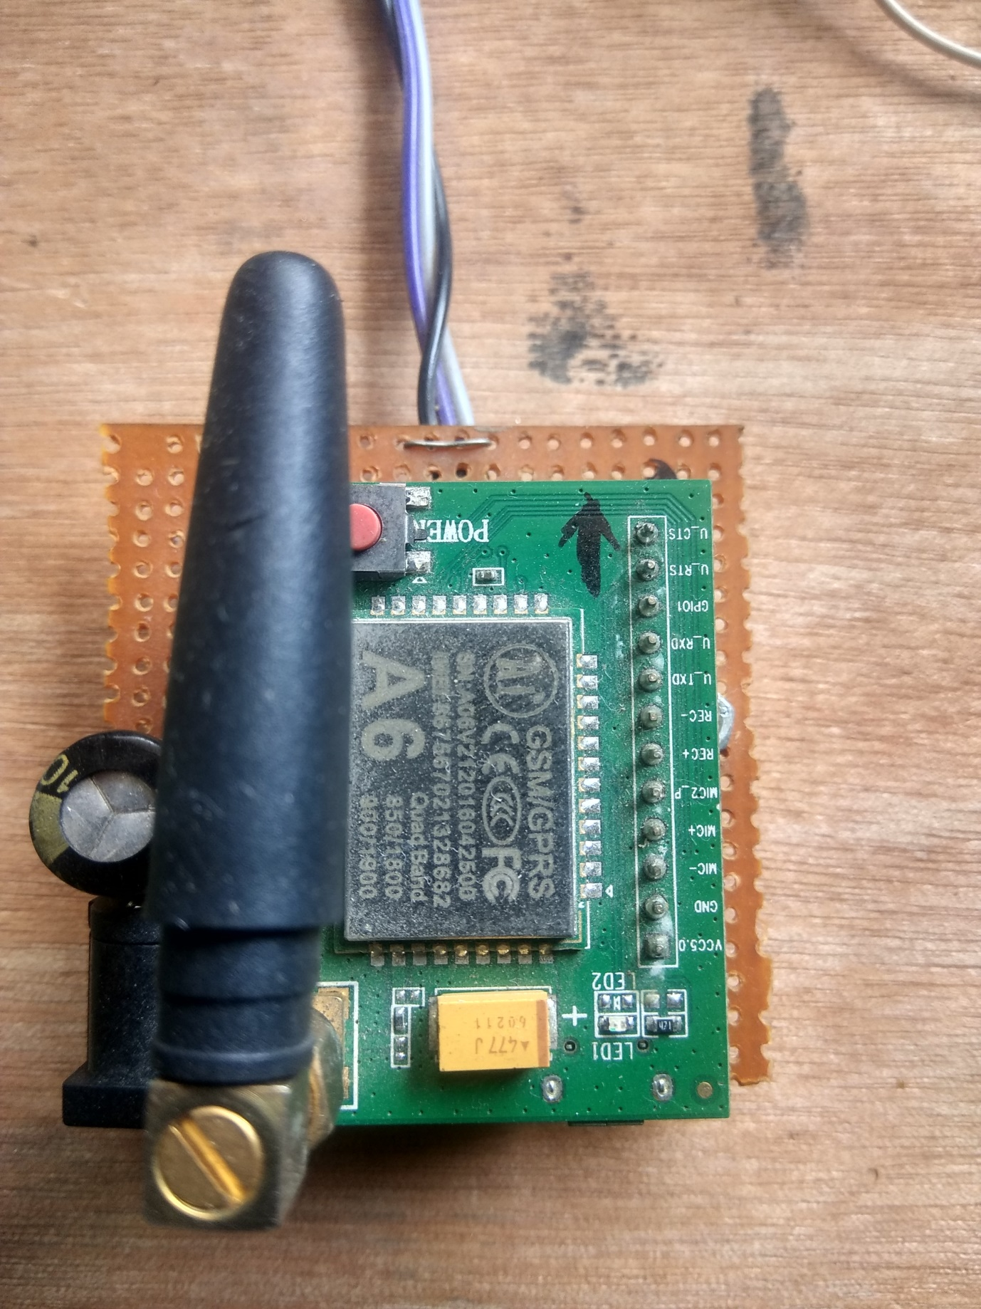

**Figure 3.4 1** A6 Module

### 

### 3.4.1 Pin Diagram

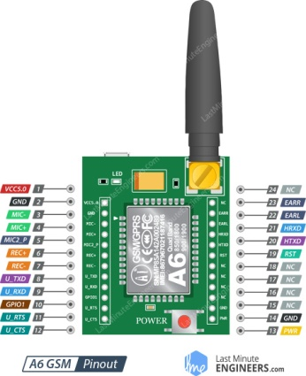

.

### 3.4.2Specifications

* Supports Quad-band: GSM850, EGSM900, DCS1800 and PCS1900
* Connect onto any global GSM network with any 2G SIM
* Make and receive voice calls using an external 8Ω speaker & electret microphone
* Facility to connect 4-pole TRRS mic and headset
* Send and receive Voice calls and SMS messages
* Class 10 GPRS with 85.6Kbps download speed and 42.8Kbps upload speed
* Consumes less than 3mA in standby mode
* 8V UART port level – compatible with Arduino, Raspberry-Pi
* Transmit Power:
  + Class 4 (2W) for GSM850/EGSM900
  + Class 1 (1W) for DCS1800/PCS1900
* Supports serial-based AT Command Set
* Accepts Micro SIM Card

## 3.5 16X2 Alpha-Numeric LCD

LCD (Liquid Crystal Display) screen is an electronic display module and find a wide range of applications. A 16x2 LCD display is very basic module and is very commonly used in various devices and circuits. These modules are preferred over seven segments and other multi segment LEDs. The reasons being: LCDs are economical; easily programmable; have no limitation of displaying special & even custom characters (unlike in seven segments), animations and so on.

A **16x2 LCD** means it can display 16 characters per line and there are 2 such lines. In this LCD each character is displayed in 5x7 pixel matrix. This LCD has two registers, namely, Command and Data.

The command register stores the command instructions given to the LCD. A command is an instruction given to LCD to do a predefined task like initializing it, clearing its screen, setting the cursor position, controlling display etc. The data register stores the data to be displayed on the LCD. The data is the ASCII value of the character to be displayed on the LCD.

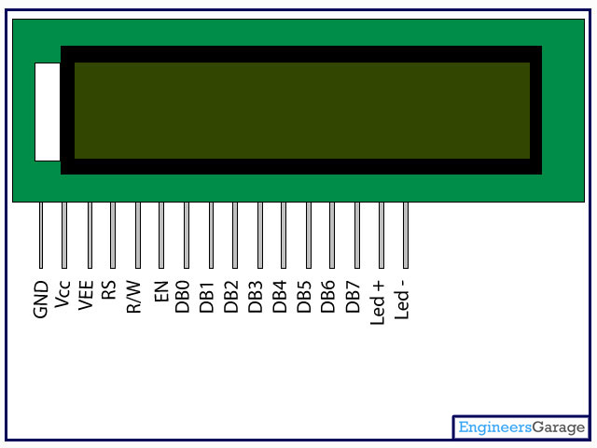

Figure 3.6 1 Pin Diagram 16X2 Alphanumeric LCD

16X2 LCD is used in our project to display the working of the modules. The pin configuration of the microcontroller is shown in figure given below.

**3.6.1 Pin Description**

|  |  |  |
| --- | --- | --- |
| **Pin No** | **Function** | **Name** |
| 1 | Ground (0V) | Ground |
| 2 | Supply voltage; 5V (4.7V – 5.3V) | Vcc |
| 3 | Contrast adjustment; through a variable resistor | VEE |
| 4 | Selects command register when low; and data register when high | Register Select |
| 5 | Low to write to the register; High to read from the register | Read/write |
| 6 | Sends data to data pins when a high to low pulse is given | Enable |
| 7 | 8-bit data pins | DB0 |
| 8 | DB1 |
| 9 | DB2 |
| 10 | DB3 |
| 11 | DB4 |
| 12 | DB5 |
| 13 | DB6 |
| 14 | DB7 |
| 15 | Backlight VCC (5V) | Led+ |
| 16 | Backlight Ground (0V) | Led- |

**Figure 3.6 2** Pin Diagram of 16×2 LCD module

**3.6.2 Features of 16×2 LCD module**

* Operating Voltage is 4.7V to 5.3V
* Current consumption is 1mA without backlight
* Alphanumeric LCD display module, meaning can display alphabets and numbers
* Consists of two rows and each row can print 16 characters.
* Each character is build by a 5×8 pixel box
* Can work on both 8-bit and 4-bit mode
* It can also display any custom generated characters
* Available in Green and Blue Backlight

**3.6.3 16x2 Display Equivalents**

* Dot Matrix LED Display
* 7-Segment LED Display,
* OLED Display,
* TFT LCD Screen Display

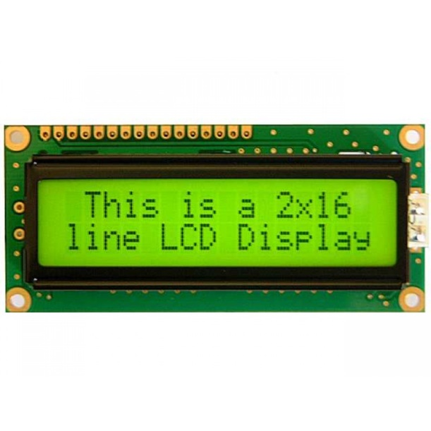

Figure 3.6 3 Display picture of LCD

# 4.1 IDE (Integrated Development Environment)

An Integrated Development Environment (IDE) is an application that facilitates application development. In general, an IDE is a graphical user interface (GUI)-based workbench designed to aid a developer in building software applications with an integrated environment combined with all the required tools at hand.

All of them have a text editor with syntax highlighter. It allows for code to be written and highlighted (key words, variables, strings, numbers, are in a different colour so that they are easier to see and read). All of them have a builder that translates the code we've written into the actual program.

Depending on the language they allow for real-time show of the result (for example web-pages). Some of them have the ability to see Code Coverage (how much of your code is actually used, really useful and interesting to see the results!).

Even a simple search for IDEs will turn up quite a few choices. IDEs are available from Open Source communities, vendors, and software companies. They range from free to pricing dependent upon the number of licenses required. There isn't a standard for IDEs and each has its own capabilities, along with strengths and weaknesses. Generally, an IDE provides an easy-to-use interface, automates development steps, and allows developers to run and debug programs all from one screen. It can also provide the link from a development operating system to an application target platform, like a desktop environment, smart phone or microprocessor.

Most common features, such as debugging, version control and data structure browsing, help a developer quickly execute actions without switching to other applications. Thus, it helps maximize productivity by providing similar user interfaces (UI) for related components and reduces the time taken to learn the language. An IDE supports single or multiple languages.

The concept of IDE evolved from simple command based software which was not as useful as menu-driven software. Modern IDEs are mostly used in the context of visual programming, where applications are quickly created by moving programming building blocks or code nodes that generate flowchart and structure diagrams, which are compiled or interpreted.

Selecting a good IDE is based on factors, such as language support, operating system (OS) needs and costs associated with using the IDE etc.

A collection of utilities combined in to single desktop application that does the following

* check the grammar i.e. syntax of the programming language
* code build- converting the program in to machine readable code i.e. executable code
* Easy maintenance of source code by facilitating dependency management & refactoring
* documentation about the code
* IDE increases the productivity of the programmer a lot

4.2 1: Arduino Code – Sending SMS

Let’s program our Arduino to send an SMS to any phone number you wish. Before trying the sketch out, you need to enter the phone number. Search for the string ZZxxxxxxxxxx and replace ZZ with county code and xxxxxxxxxx with the 10 digit phone number.

#include <SoftwareSerial.h>

//Create software serial object to communicate with A6

SoftwareSerial mySerial(3, 2); //A6 Tx & Rx is connected to Arduino #3 & #2

void setup()

{

//Begin serial communication with Arduino and Arduino IDE (Serial Monitor)

Serial.begin(9600);

//Begin serial communication with Arduino and A6

mySerial.begin(9600);

Serial.println("Initializing...");

delay(1000);

mySerial.println("AT"); //Once the handshake test is successful, it will back to OK

updateSerial();

mySerial.println("AT+CMGF=1"); // Configuring TEXT mode

updateSerial();

mySerial.println("AT+CMGS=\"+ZZxxxxxxxxxx\"");//change ZZ with country code and xxxxxxxxxxx with phone number to sms

updateSerial();

mySerial.print("Smart Home Initialized!"); //text content

updateSerial();

mySerial.write(26);

}

void loop()

{

}

void updateSerial()

{

delay(500);

while (Serial.available())

{

mySerial.write(Serial.read());//Forward what Serial received to Software Serial Port

}

while(mySerial.available())

{

Serial.write(mySerial.read());//Forward what Software Serial received to Serial Port

}

}

The sketch is almost same as earlier except below code snippet. Once the connection is established, we send below AT commands:

**AT+CMGF=1**: – Selects SMS message format as text. Default format is [**P**rotocol **D**ata **U**nit](https://en.wikipedia.org/wiki/Protocol_data_unit)(PDU)

**AT+CMGS=+ZZxxxxxxxxxx** – Sends SMS to the phone number specified. The text message entered followed by a ‘Ctrl+z’ character is treated as SMS. ‘Ctrl+z’ is actually a 26th non-printing character described as ‘substitute’ in [ASCII table](https://www.asciitable.com/). So, we need to send 26DEC (1AHEX) once we send a message.

mySerial.println("AT+CMGF=1"); // Configuring TEXT mode

updateSerial();

mySerial.println("AT+CMGS=\"+ZZxxxxxxxxxx\"");//change ZZ with country code and xxxxxxxxxxx with phone number to sms

updateSerial();

mySerial.print("Smart Home Initialized"); //text content

updateSerial();

mySerial.write(26);

The loop is kept empty as we want to send SMS only once. If you wish to send SMS one more time, just hit the RESET key on your Arduino.

### 4.2.2: Arduino Code – Reading SMS

Now let’s program our Arduino to read incoming messages. This sketch is very useful when you need to trigger an action when a specific SMS is received. For example, when the Arduino receives an SMS, you can instruct it to turn on or off a relay.

#include <SoftwareSerial.h>

//Create software serial object to communicate with A6

SoftwareSerial mySerial(3, 2); //A6 Tx & Rx is connected to Arduino #3 & #2

void setup()

{

//Begin serial communication with Arduino and Arduino IDE (Serial Monitor)

Serial.begin(9600);

//Begin serial communication with Arduino and A6

mySerial.begin(9600);

Serial.println("Initializing...");

delay(1000);

mySerial.println("AT"); //Once the handshake test is successful, it will back to OK

updateSerial();

mySerial.println("AT+CMGF=1"); // Configuring TEXT mode

updateSerial();

mySerial.println("AT+CNMI=1,2,0,0,0"); // Decides how newly arrived SMS messages should be handled

updateSerial();

}

void loop()

{

updateSerial();

}

void updateSerial()

{

delay(500);

while (Serial.available())

{

mySerial.write(Serial.read());//Forward what Serial received to Software Serial Port

}

while(mySerial.available())

{

Serial.write(mySerial.read());//Forward what Software Serial received to Serial Port

}

}

The sketch is similar as earlier except below code snippet. Once the connection is established, we send below AT commands:

**AT+CMGF=1** – Selects SMS message format as text. Default format is **P**rotocol **D**ata **U**nit (PDU)

**AT+CNMI=1,2,0,0,0** – specifies how newly arrived SMS messages should be handled. This way you can tell the A6 module either to forward newly arrived SMS messages directly to the PC, or to save them in message storage and then notify the PC about their locations in message storage.

Its response starts with **+CMT:** All the fields in the response are comma-separated with first field being phone number. The second field is the name of person sending SMS. Third field is a timestamp while forth field is the actual message.

mySerial.println("AT+CMGF=1"); // Configuring TEXT mode

updateSerial();

mySerial.println("AT+CNMI=1,2,0,0,0"); // Decides how newly arrived SMS messages should be handled

updateSerial();

Note that **this time we have NOT kept the loop function empty** as we are polling for newly arrived SMS messages.

5.1 CONCLUSION

Automating your home is feasible these days. Although, it has been around for a while, it has not been a potential option for a lot of people due to its immense cost. However, thanks to the development of Android and Arduino technologies, practically anyone can implement some kind of automation at their home. After the analysis of latest developments, such as Zigbee, Z-Wave, Android@Home, Domotichome, X10, Insteon, we have highlighted diﬀerent decision criterions and brought out the advantages and disadvantages of every system.

Although microcontrollers have been in home automation solutions for a long time, none of them have been open-hardware and open-source. The emerging of microcontrollers like Arduino fosters the development of smart homes solutions. With the add-on modules Arduino gives us endless opportunities to link and conﬁgure diﬀerent devices in our home. By implementing the wireless-based systems, we showed how Arduino can be adapted in a smart home environment.

This Project could be design in nature by using handy portable key fob facility. The cost of the project is also not that high and it is also take less time to consume. This Project can be useful for the people who want to use unconventional way to use switches and that can help to reduce exceeding use of energy and power, such as electricity. So, overall it could be a beneficiary project for the practical, busy and urban life.

We are using RF module in our project. Generally, an RF module is a small size electronic device, that is used to transmit or receive radio signals between two devices. The main application of RF module is an embedded system to communicate with another device wirelessly. This communication may be accomplished through radio frequency communication. The frequency of RF module which we are using in our project is 433-434 Mhz.

This project is very useful for electricity saving purpose because we can regulate the switch very quickly otherwise due to laziness we avoid to on/off them.

Google announced the release of Android@Home by summer 2012 and it is expected that this solution will gain popularity in the market. This may revolutionize the home automation domain since a big number of people already have an Android device at their disposal for controlling devices. Furthermore, Google is a billion-dollar corporation that has the knowledge for developing a system that is intuitive and feasible for practically everyone. Lastly, a lot of devices already have Android capabilities so integrating them in a home environment will be easier. However, the problem of standardization remains unresolved. The possibility of a global standard is remote.

## 5.2 Future Scope

Future scope for the home automation systems involves making homes even smarter. Homes can be interfaced with sensors including motion sensors, light sensors and temperature sensors and provide automated toggling of devices based on conditions. More energy can be conserved by ensuring occupation of the house before turning on devices and checking brightness and turning off lights if not necessary. The system can be integrated closely with home security solutions to allow greater control and safety for home owners. The next step would be to extend this system to automate a large scale environment, such as offices and factories.

## 5.3 Uses & Targets

## 

Since the concept of home automation is so broad, it is almost impossible to come up with a detailed specification of what a system for intelligent houses should be able to do. As has been stated before, the main purpose is to inter connect all kinds of devices in a house to provide easier control, automatic regulation and new possibilities.

One way to approach the task of building a system for intelligent houses would be to simply identify a number of tasks that could be useful and then build a system to perform these tasks. This has already been done, however, and the obvious limitations of such a system make it doubtful that it could ever bring on the kind of revolution in thinking of technical equipment that is associated with intelligent houses, and necessary for the market segment to grow large.

Therefore this thesis argues that a new way of thinking in the area of home automation is necessary if it is ever going to go beyond small systems for people interested in high tech equipment and systems related to management of larger buildings. The solution proposed in this thesis is a very adaptable and general structure that focuses on dynamic behaviour, flexibility, open interfaces and transparency, specifically targeted at easy adaptation and development for third part manufacturers

One possibility would be to make a system like this open source, in order to make it develop and adapt faster to what people actually wants. It will give birth to new ideas that no single organisation could ever come up with.

As for the test right at has been built as a part of this thesis, focus has mainly been aimed at building end devices, control devices and protocol modules that can demonstrate the possibilities of the system architecture. The choices would not necessarily be the same if the purpose was to develop devices and modules for a commercial system, even though the ones developed probably would be marketable if redesigned for that purpose.

## 5.4 Applications

## 

* The home automation systems are used for controlling the indoor & outdoor lights
* To regulate heat and ventilation in house and offices.
* For air conditioning in the house.
* To lock or unlock the doors & gates.
* To control electrical & electronic appliances without the need of a physical switch.
* For using various control systems with appropriate sensors.

## 5.5 Result & Analysis

This thesis set out to analyze the background and necessary conditions for success in the area of intelligent houses. Furthermore, an analysis of the current state of the market and development was to be made, and future trends to be extrapolated.

Finally a prototype was to be created to show the possibilities in the area. The background concludes that both the technology of the market and the potential customers should be ready for intelligent houses as a natural next step in the development. This conclusion is inherently impossible to verify. In the current development, two trends could be discerned.

The first one was a rather large market in the area of larger scale automation of ofﬁce buildings, apartment buildings and the like, focused mainly in ﬁelds like ventilation, heating, lightning and elevators. The other trend was focusing on the consumer market, but suffered from locked standards and incompatibility.

Based on the analysis, this thesis focused on a simple, yet powerful solution that would allow both the existing systems in home automation and third part manufacturers, not traditionally within the market, to integrate their products in one solution. To make this possible, a design with a great focus on ﬂexibility, dynamic behaviour and transparency was chosen.

There are also some parts of the design that might be improved. Our message system, though fairly simple, could have been better structured and intuitive. It is not completely clear which message type to use for different purposes.

## 5.6 Limitations

## 

* The analysis of background and current and future development is quite shallow due to the time limitations. In order to get a better analysis, more information gathering, surveys and interviews would have to be conducted.
* This, of course, also affects our design choices for the test rig, but the most fundamental assessments in that area should be correct. It is harder to tell if the list of applications for intelligent houses really reflects the market’s expectations and the future of the field.
* This thesis does not in any way bring up the security of intelligent houses in general nor the security of the prototype system. The prototype has been built with the future possibility to add security in mind, but is to be considered completely insecure in its current state.
* Primarily because of the complexity and the size of the base system of the prototype, the number of protocol modules and devices is somewhat limited.
* To compensate for this, the rig features a number of simulations of devices that help to further demonstrate the possibilities of the system. To save costs and time, our RFID-reader device only has a small reader, with a range of a couple of centimetres.
* In a real system these would be scaled up to cover whole doorways. Finally, some kind of sensor to judge direction would probably be necessary for robustness.

## 5.7 References

Baris Yuksekkaya, A. Alper Kayalar, M. Bilgehan Tosun, M. Kaan Ozcan, and Ali Ziya Alkar “A GSM, Internet and Speech Controlled Wireless Interactive Home Automation System”, 2006, IEEE Transactions on Consumer Electronics, Vol. 52(3) , pp. 837 - 843. [2]

Rozita Teymourzadeh,Salah Addin Ahmed,Kok Wai Chan and Mok Vee Hoong , “Smart Home Automation System”, 2013, IEEE Conference on Systems, Process & Control, Kuala Lumpur, Malaysia.

Md. Faijul Haque, Sabrina Hossain, Ayesha Siddika and Md. Nasfikur R. Khan, "Smart Home Automation System based on Environmental Monitoring System," National Conference on Electronics and ICT, Dhaka, 2017.

# Book Embedded Systems and Robotics- Basics and Advance HPE-ERB&A-v1.0

# MN Bennasar, A Kebir proceedings of the 14th International Middle East Power Systems Conferences (MEPCON’10) Cario University, Paper ID 206,456-470,2010.

# Shruti Srivastava, Jageshwar Rawat, Amit Agarwal (International journal of engineering research 1 (2) 44-47, 2012.

# Arthur A Mouyard, Michael V Hamby, Paul A Tomaszek US Patent 4,254,453, 1981.

# Wilber C Steward, Albert Pica, William R Roach US Patent 4,892,391, 1990.

# Malgosia Kaczmarek, A Dyadyusha, Sergei Slussarernko, IC Khoo

# Journal of applied physics 9(5), 2616-2623, 2004.

# Scott Chiu, Issy Kipnis, Marc Loyer,Jan Rapp, David Westherg Jonas Johnson Peter

# IEEE Journal of Solid-State Circuits 42(12), 2822-2833, 2007.

# Toshihiko Komine, Masao Nakagawa IEEE transactions on consumer Electronics 50(1), 100-107, 2004.

# Hazel Smith, Roger Dean Edinburg University Press, 2009.

# Siddha Pimputkar, James S Speck, Seven P DenBaars, Shuji Nakamura

# Nature photonics 3(4), 180, 2009.

# Rahul Magoon, Alyosha Molnar, Jeff Zachan, Geoff Hatcher, Woogeun Rhee

# IEEE Journal of Solid State Circuits 37(12), 1710-1720, 2002.

# Craig Matsuura, Greg Cooper, Thomas Leishman

# US Patent App. 12/098, 308, 2010.

# Inderpreet Kaur International jornal of Advance computer science and applications 1(6), 60-65, 2010.

# Samak R Das, Silvia Chita, Nina Peterson, Behrooz A Shiraz, Medha Bhandkamar.

# Pervasive Computing and Communications Workshop (PERCOM Workshops), 2011 IEEE International Conferences on, 141/146, 2011.

# 

# Appendix

device 16C72

xtal = 4

input porta

output portb

output portc

low portc

all_digital=true

declare rsin_pin portc.4

rsin_timeout=100

declare serial_baud 300

dim a,b,c,d,e,f,g,h as byte

e=0

f=0

g=0

h=0

dim arr[3] as byte

high portc.6'gate close

delayms 1000

low portc.6

cls

print at 1,1,"ENERGY EFFICIENT"

print at 2,1,"SMART FUTURE HOM"

delayms 2000

loop:

print at 1,1,"ENERGY EFFICIENT"

print at 2,1,"SMART FUTURE HOM"

a=rsin

if a="$" then

rsin str arr

if arr[0]="V"

if arr[1]="E"

if arr[2]="H"

print at 1,1,"VEHICLE DETECTED"

print at 2,1," GATE OPENED "

high portc.5'gate open

delayms 1000

low portc.5

goto loop2

endif

endif

endif

endif

goto loop

loop2:

a=porta.3

delayms 10

if a=1 then

print at 1,1,"VEHICLE ENTERED "

high portc.6

high portc.0'main light

delayms 1000

low portc.6

print at 1,1," MAIN LIGHT ON "

print at 2,1," GATE CLOSED "

goto loop3

endif

goto loop2

loop3:

b=porta.2

delayms 10

if b=1 then

delayms 1000

e=e+1

if e=1 then

print at 1,1,"PERSON ENTERED "

print at 2,1,"ROOM LIGHT ON "

delayms 1000

print at 2,1," "

endif

endif

if e=1 then

high portc.3'room light

print at 1,1,"ROOM LIGHT ON "

c=porta.0'tv sensor

delayms 10

if c=1 then

f=f+1

delayms 1000

endif

if f=1 then

print at 2,1,"TV ON "

high portc.1

endif

if f=2 then

f=0

print at 2,1,"TV OFF"

low portc.1

endif

d=porta.1'fan sensor

delayms 10

if d=1 then

g=g+1

delayms 1000

endif

if g=1 then

print at 2,7," FAN ON "

high portc.2

endif

if g=2 then

g=0

print at 2,7," FAN OFF"

low portc.2

endif

endif

if e=2 then

e=0

f=0

g=0

low portc.1

low portc.2

low portc.3

print at 1,1,"PERSON EXITS "

print at 2,1,"ALL LOADS OFF "

delayms 1000

goto loop4

endif

goto loop3

loop4:

b=porta.2

delayms 10

if b=1 then goto loop3

a=porta.3

delayms 10

if a=1 then

print at 1,1,"MAIN GATE OPENED"

print at 2,1," "

high portc.5

delayms 1000

low portc.5

delayms 1000

print at 1,1," MAIN GATE WILL "

print at 2,1,"CLOSE IN 5 SEC. "

delayms 5000

high portc.6

delayms 1000

low portc.6

print at 1,1,"MAIN GATE CLOSED"

delayms 1000

low portc.0

print at 2,1," MAIN LIGHT OFF "

delayms 2000

goto loop

endif

goto loop4